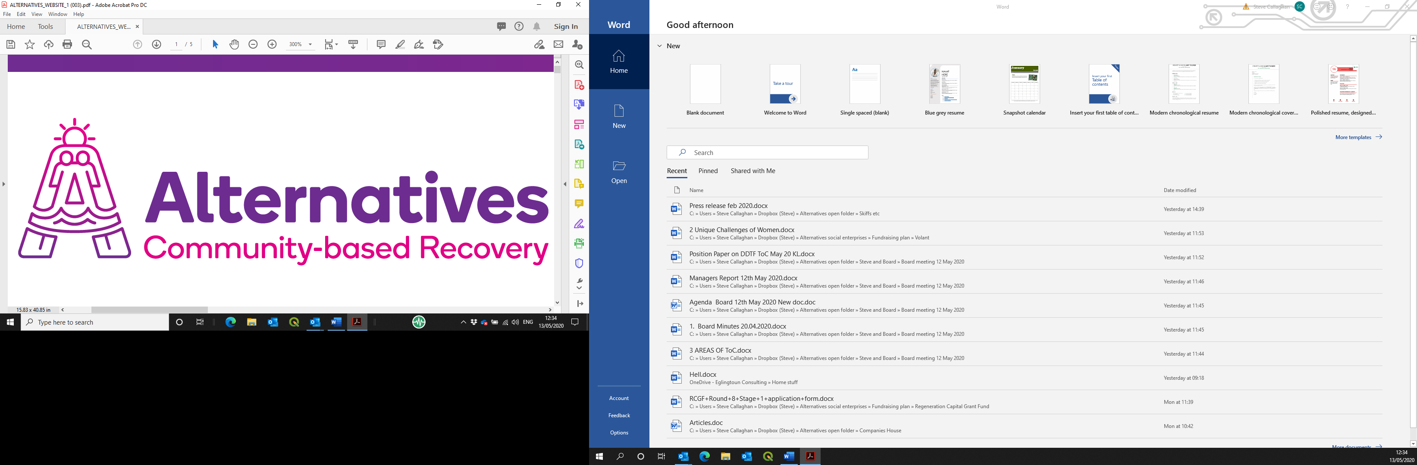

**Post of Recovery House Nightshift Support Worker**

**Application pack**

Contents

Introduction and background information 3

Applying for the post on offer 3

Alternatives West Dunbartonshire Community Drug Services (Alternatives) 3

History and achievements 3

Social enterprises 3

Job description 3

Person specification 5

Application form 6

# Introduction and background information

## Applying for the post on offer

Please read this pack in its entirety, then apply using the enclosed electronic form. This should be returned by **12.00p.m. on Friday 19th September 2025**, by email to [Ashlay@alternativeswd.org](mailto:Ashlay@alternativeswd.org) .

**Interview will take place week commencing Monday 29th September 2025**

Please add your surname to the name of the file as you save it before sending.

LATE APPLICATIONS WILL NOT BE ACCEPTED.

## Alternatives West Dunbartonshire Community Drug Services (Alternatives)

### History and achievements

Alternatives has been established since 1996 as a charitable company, with premises across West Dunbartonshire. Its operation base currently consists of:

* A main office in Quay Street, Dumbarton;
* A secondary office in Alexander Street, Clydebank;
* A 16-bed ‘Safe House’ in Jean Armour Drive, Clydebank;
* 4 x 2-bedroom ‘scatter flats’ in Drumry; and
* A catering operation within the Concord Community Centre and Deny Tank Museum, Dumbarton.

Alternatives’ core theme and purpose is to facilitate the personal journey from chaos to wholeness for individuals who have a substance dependency, by normalising a lifestyle without such a dependency.

Much of Alternatives’ core work is through its Service Level Agreement (SLA) with West Dunbartonshire Council for the delivery of community-based group work with service users in recovery from dependency on substances. Some of these service users are housed in the Safe House and associated scatter flats as part of their recovery journey, out with the SLA. The Care Inspectorate has recently awarded Alternatives a score of 6s across the board for its core work, the highest mark available and 5s for the rest, still an excellent accolade. This was the subject of a Private Member’s Motion in the Scottish Parliament during January 2020, where Alternatives and its team were praised and endorsed.

### Social enterprises

We run social enterprises as safe, therapeutic work placement opportunities, these are being developed within the operational structure, to take in a horticulture operation and an expansion of the piloted catering operation as well as a heritage based operation.

# Job description

This role may be suitable for an internal or external secondment, as part of the candidate’s continuing professional development.

**PVG Scheme Membership is required for this post.**

Alternatives operates an Equal Opportunities Policy.

**Job title**: Recovery House Nightshift Support Worker

**Place of work**: Safe As Houses Project, Clydebank

**Employer**: Alternatives West Dunbartonshire Community Drug Services (Alternatives)

**Reporting to**: Recovery House Co-ordinator, Alternatives

**Salary**: £19,656.00 per annum plus a contributory Pension Scheme of up to 6%.

**Hours**: An average of 30 hours a week over a three week shift pattern including weekends.

**Job purpose/main scope of post**:

To support the evening and overnight running of the Recovery House. This involves supporting residents of the Recovery House to maintain a safe and secure environment as they become and maintain abstinent lifestyles. The position is a waking nightshift position in a rota system. There will be additional support available through the night by way of management on call team.

* To provide and maintain a safe and secure environment for service users within the Recovery House.
* Assist with the evening and morning medications and record appropriately.
* To risk assess situations while maintaining a safe working environment for self and others.

* To be able to utilise the on-call system appropriately.
* To ensure an accurate shift report is passed onto those working the following shift.
* To provide support to service users throughout the night as required.
* To ensure Recovery House policies and procedures are adhered to by residents.
* To complete nightly welfare checks as required and record.
* To record work undertaken in a suitable form as designated by the Line Manager and to gather data and maintain data gathering systems.
* To undertake administration tasks as required, including updating of the in house database system.
* To actively promote the services provided by Alternatives in line with policy guidelines, protocol and service philosophy.
* To work as part of a team towards the aims of service users in line with agreed working practice and strategies.
* To complete overnight housekeeping tasks in accordance with checklist.
* To undertake such training programmes as may assist this agency and enhance personal development.
* To participate in formal consultation and supervision as required.
* To undertake such other duties, appropriate to the grade, as may be delegated by the Line Manager.

# Person specification

|  |  |  |  |
| --- | --- | --- | --- |
| **Specification** | **Essential** | **Desirable** | **How demonstrated** |
| **Qualifications** | Relevant SVQ level 2 qualification (or willingness to work towards a qualification) |  | Application form |
| **Knowledge and Experience** | Willingness to work within appropriate legislation processes and procedures. |  | Application form; detailed in interview and references |
| **Competencies** | Good quality written and verbal skills.  A good knowledge of IT and Administration Systems.  Ability to manage conflict  An understanding of working with families experiencing hardship.  Ability to work on own and as part of a team.  A person-centred approach to working with people experiencing drug problems.  An awareness of needs of people experiencing drug problems.  Must be able to work irregular hours and weekends.  Ability to recognise and report concerns about the well-being of children and vulnerable service users. | An understanding of vulnerable adults and trauma  Previous experience of inter-agency working.  Residential work experience  Technical skills (simple IT)  Attention to detail | Application form;  Competency based interview; references |

# Application form

|  |  |  |
| --- | --- | --- |
| **A** | **Post details** | |
| **Post Title** | | Recovery House Nightshift Support Worker |
| **Employer** | | Alternatives West Dunbartonshire Community Drug Services |

|  |  |  |  |  |  |
| --- | --- | --- | --- | --- | --- |
| **B** | **Personal details** | | | | |
| **Surname:**Click or tap here to enter text. | | **First name(s):**Click or tap here to enter text. | | **Known as:**Click or tap here to enter text. | |
| **Address and Postcode:** | | Click or tap here to enter text. | | | |
| **Telephone (home):** | | Click or tap here to enter text. | **National Insurance No:** | | Click or tap here to enter text. |
| **Telephone (mobile):** | | Click or tap here to enter text. | **Email address:** | | Click or tap here to enter text. |

|  |  |  |  |
| --- | --- | --- | --- |
| **C** | **Referees** | | |
| (we will only contact if successful at interview) | | **First reference** | **Second reference** |
| **Name:** | | Click or tap here to enter text. | Click or tap here to enter text. |
| **Role:** | | Click or tap here to enter text. | Click or tap here to enter text. |
| **Organisation/personal:** | | Click or tap here to enter text. | Click or tap here to enter text. |
| **Address:** | | Click or tap here to enter text. | Click or tap here to enter text. |
| **Postcode:** | | Click or tap here to enter text. | Click or tap here to enter text. |
| **Telephone:** | | Click or tap here to enter text. | Click or tap here to enter text. |
| **Email address:** | | Click or tap here to enter text. | Click or tap here to enter text. |

|  |  |  |
| --- | --- | --- |
| **D** | **Additional information** | |
| **Notice required by current employer:** | | Click or tap here to enter text. |
| **Are you allowed to work in the UK?** | | Click or tap here to enter text. |
| **What driving licence do you hold?** | | Click or tap here to enter text. |
| **Penalty points current:** | | Click or tap here to enter text. |

|  |  |  |  |
| --- | --- | --- | --- |
| **E** | **Education and Qualifications** | | |
| **Attainment** | | **Results obtained** | **Year** |
| Click or tap here to enter text. | | Click or tap here to enter text. | Click or tap here to enter text. |

|  |  |  |
| --- | --- | --- |
| **F** | **Other training and experience** | |
| **Description** | | **When undertaken/achieved** |
| Click or tap here to enter text. | | Click or tap here to enter text. |

|  |  |  |  |  |
| --- | --- | --- | --- | --- |
| **G** | **Membership of professional bodies** | | | |
| **Institution** | | **Class of membership** | **From** | **To** |
| Click or tap here to enter text. | | Click or tap here to enter text. | Click or tap here to enter text. | Click or tap here to enter text. |

|  |  |  |  |  |
| --- | --- | --- | --- | --- |
| **H** | **Employment history** | | | |
| **Employer (most recent first)** | | **Role held** | **Description of duties** | **Timeframe** |
| Click or tap here to enter text. | | Click or tap here to enter text. | Click or tap here to enter text. | Click or tap here to enter text. |

|  |  |
| --- | --- |
| **I** | **Health** |
| If offered employment, this will be subject to a required medical questionnaire. Please state that you will be prepared to complete such a documentClick or tap here to enter text. | |

|  |  |
| --- | --- |
| **J** | **Supporting information** |
| Please give enough information for us to assess your application against the person specification | |
| Click or tap here to enter text. | |

|  |  |  |  |  |
| --- | --- | --- | --- | --- |
| **K** | **Declaration** | | | |
| Alternatives posts are covered by the Rehabilitation of Offenders Act 1974.  Before an offer of appointment, an Enhanced Disclosure Scotland check will be carried out.   * I agree to an Enhanced Disclosure Scotland check being carried out. * I certify that all of the information I have provided is accurate and truthful; I realise that supplying incorrect or untruthful information on the form may form grounds for summary dismissal without notice. | | | | |
| **Signed:** | | Click or tap here to enter text. | **Date:** | Click or tap here to enter text. |